Chapter 17, Problem 28.

Obtain the trigonometric Fourier series for the voltage waveform shown in
Fig. 17.66.
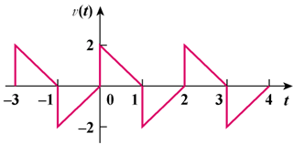

–2

Figure 17.66
For Prob. 17.28.

